Detonating Baby Felines

Software Design Document

**Introduction** **2**

Purpose 2

Scope 2

**System Overview** **3**

**System Architecture** **3**

Web UI 3

Lobby API 3

Game API 4

Game State 4

Decomposition Description 4

Lobby API 4

Game API 4

**State** **5**

**User Interface** **6**

Lobby 6

Game Board 8

# 

# 

# 

# Introduction

## Purpose

This software design document describes the architecture and system design of Detonating Baby Felines. This document will also describe the state flow of the game.

## Scope

The goals of the software are to provide a means to enjoy the Exploding Kittens card game to the computer. The game will provide multiplayer functionality with a lobby that will allow a player to create or join any game in progress.

# System Overview

A user will be able to log into the server, create a game, and join a game. The game will utilize a websocket connection between clients of an instance of the game and the server in order to maintain continuity between players. Each player will be able to play a number of cards that have various effects. A player’s turn ends when they draw a card. If that card is a specific card, that player “dies” and is no longer active.

# System Architecture

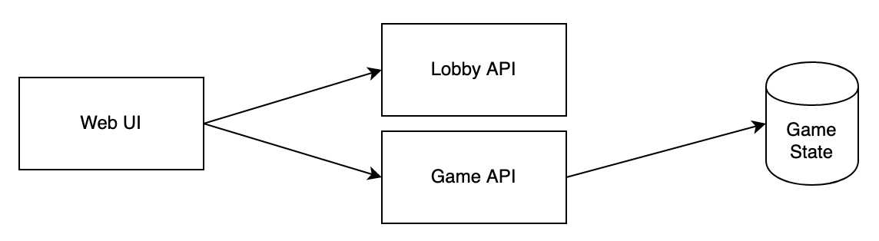

### Web UI

All user interaction occurs here. Displayed via static, generated files. Maintains a copy of game rules.

### Lobby API

Basic API that maintains a list of games and the players associated with those games. Defines valid numbers of players.

### Game API

Application that stores the valid moves players are capable of making. Game state is validated here. Gameplay moves are validated here and relayed to other players as events.

### Game State

The game state is stored in a datastore along with logging information.

## Decomposition Description

### Lobby API

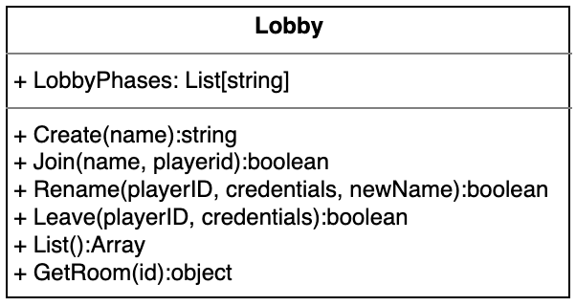

### Game API

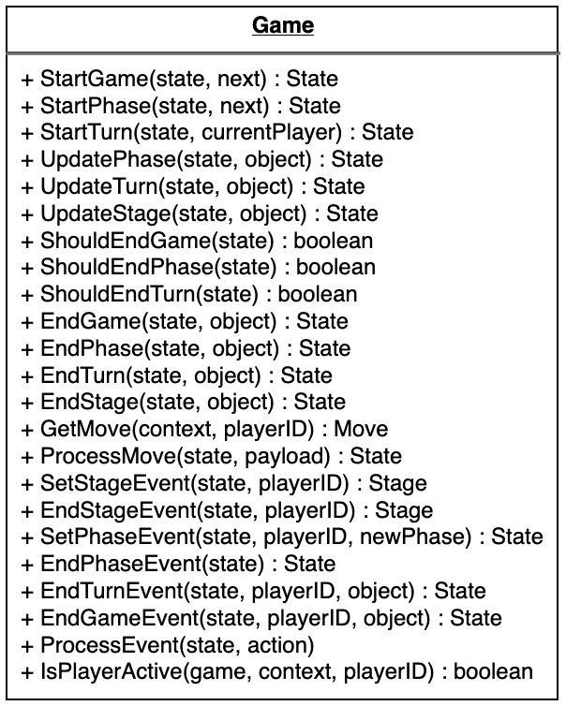

# State

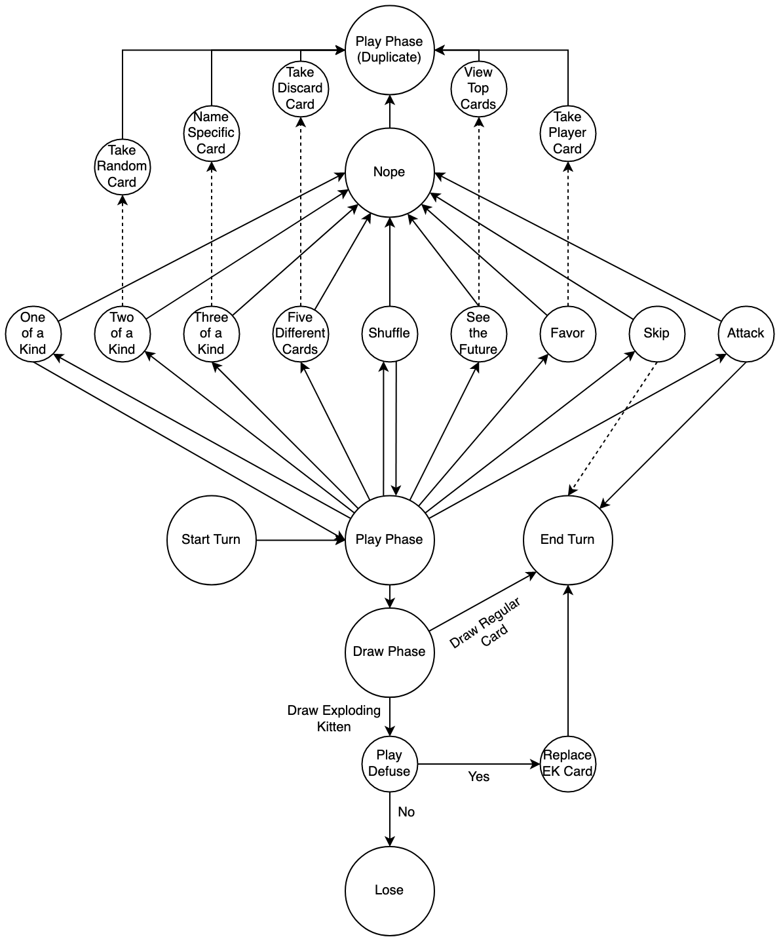

# User Interface

## Lobby

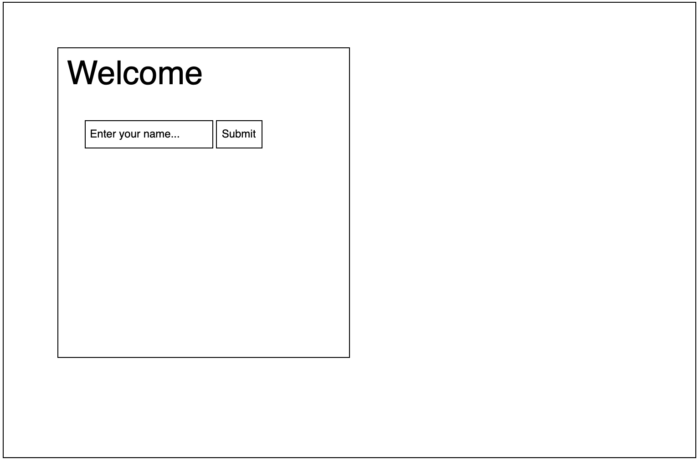

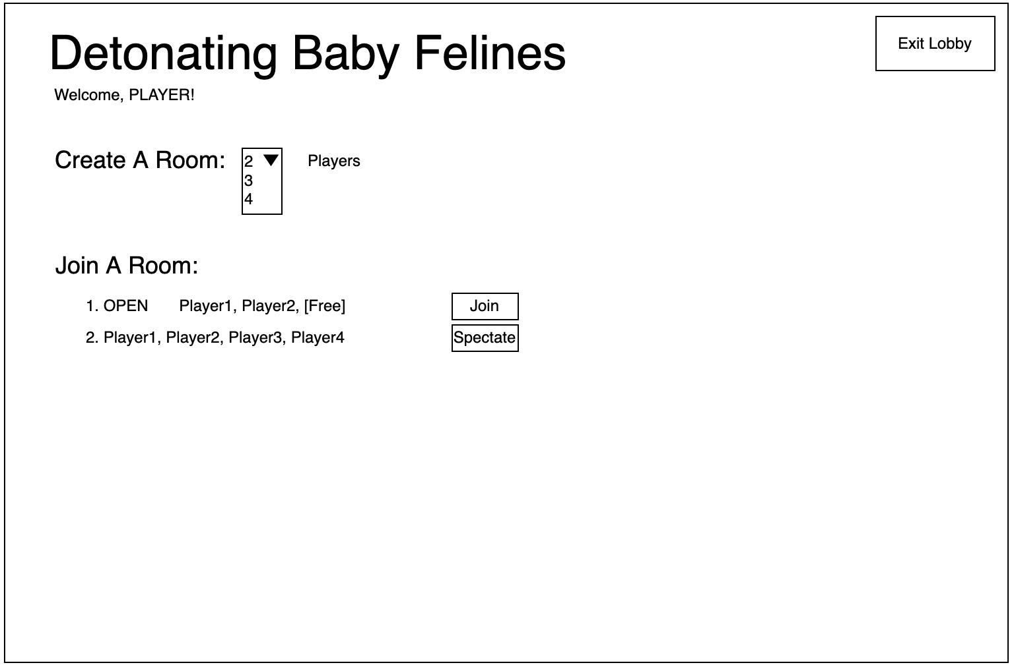

## Game Board

